sudo apt-get update

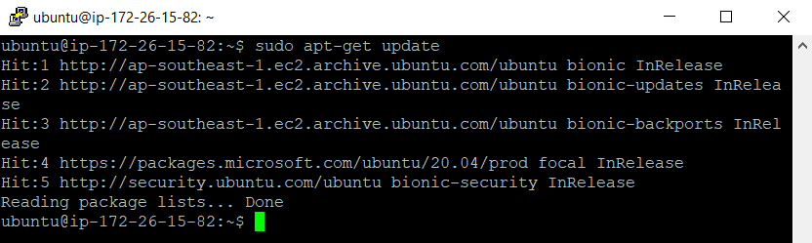

sudo apt upgrade

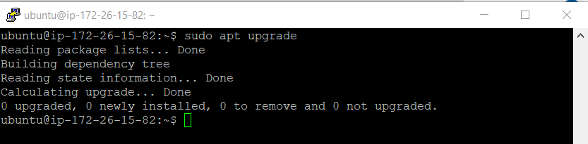

Sudo apt install zsh

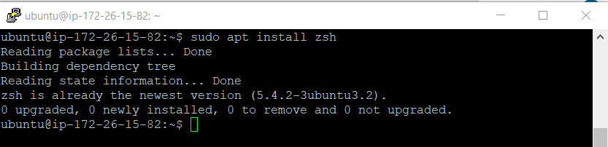

sudo apt-get install powerline fonts-powerline

